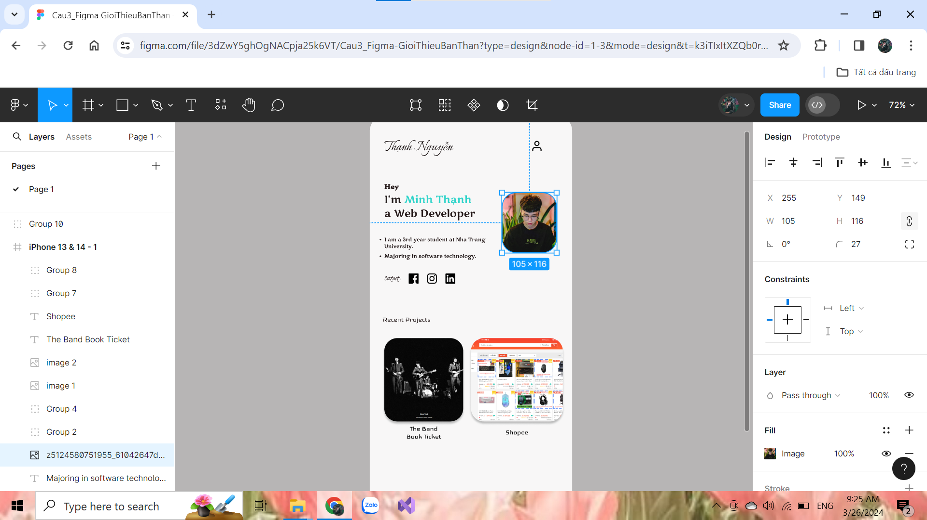

Link figma: https://www.figma.com/file/3dZwY5ghOgNACpja25k6VT/Cau3_Figma-GioiThieuBanThan?type=design&node-id=1%3A3&mode=design&t=k3iTIxItXZQb0r34-1